**DATA FLOW DIAGRAMS AND USER STORIES**

**Date** : 15 Nov 2022

**Project Name** : Early Detection Of Chronic Kidney Disease Using Machine Learning

**Team ID** : PNT2022TMID20701

**Team Lead** : Swetha.S

**Team Members** : AnuNandhini J, Ramya R, Subashini T

**DATA FLOW DIAGRAM:**

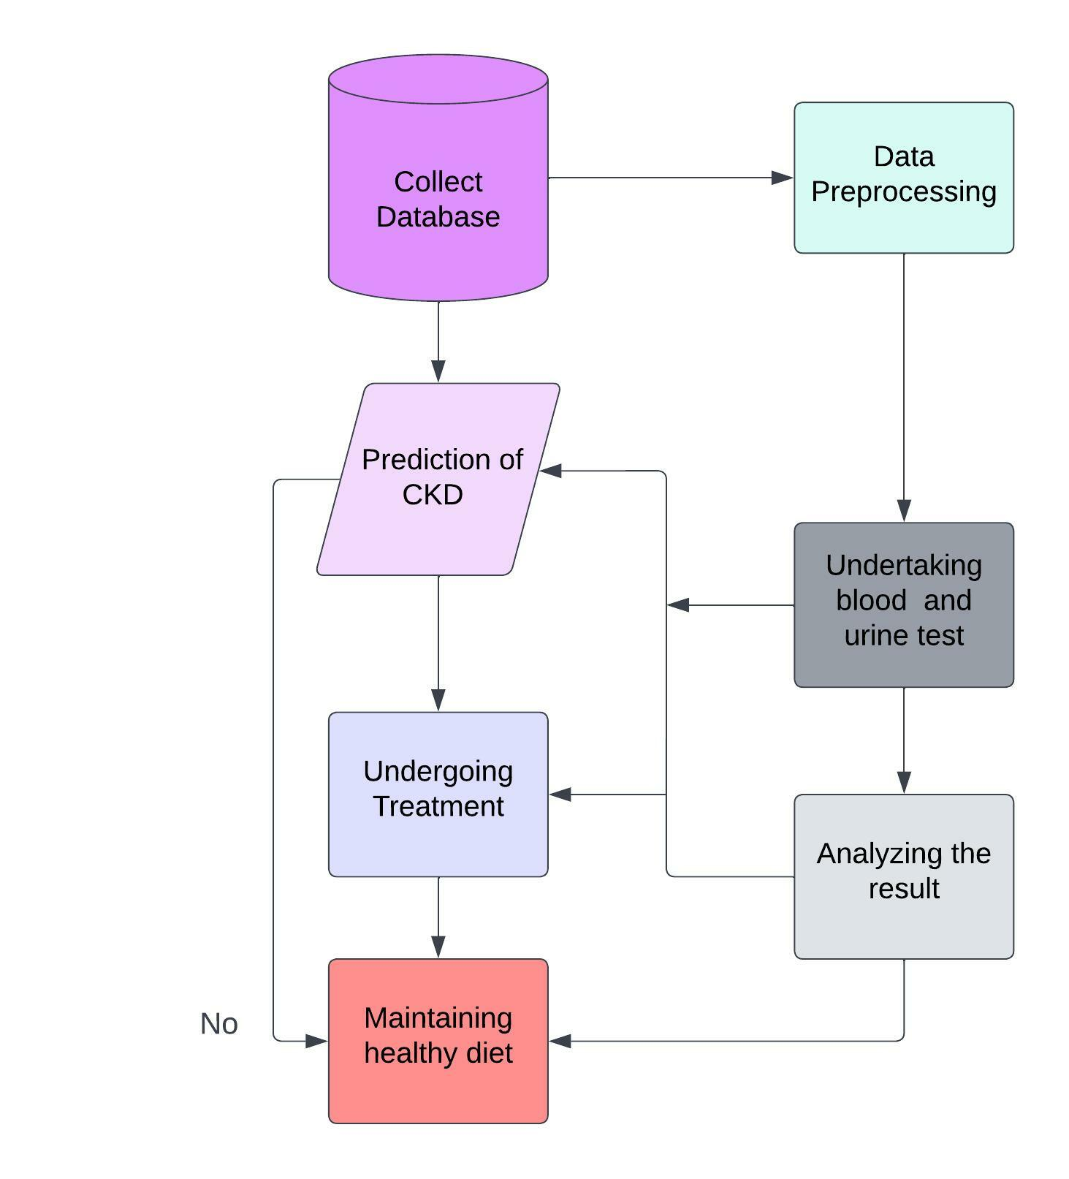

**USER STORIES:**

|  |  |  |  |  |  |  |
| --- | --- | --- | --- | --- | --- | --- |
| **User Type** | **Functional Requirement (Epic)** | **User Story Number** | **User Story / Task** | **Acceptance criteria** | **Priority** | **Release** |
| Customer (Mobile user) | Create Home Page | USN-1 | As a user, I can collect the database of  patients. | I can access my home page | High | Sprint-1 |
| User | Preprocessing | USN-2 | As a user, I can preprocess the data from the database. | I can convert the raw data. | High | Sprint-2 |
| User | Testing | USN-3 | As a user, I can make the patients undergo two kinds of test (urine and  blood test) | I can do the test in the dashboard. | Low | Sprint-3 |
| User | Analysis | USN-4 | As a user, I can analyze  the test results | I can view the test results. | Medium | Sprint-4 |
| User | Prediction | USN-5 | As a user, I can predict CKD with the test results | I can make prediction. | High | Sprint-4 |
| User | Recovering process |  | As a user, I can make the affected  patients to take treatment | I can give details about treatment process. | High | Sprint-4 |
| User | Awareness |  | As a user, I can advise the patients to maintain a healthy diet | I can create an awareness page. | High | Sprint-4 |